**Catalog #: XXX**

**PRODUCT NAME**

Monoclonal antibody (murine IgG1) 5A6 specific for *S. aureus* CP8

**Lots #: 1, 2, 3, 4, and 5**

[Services@ibtbioservices.com](mailto:Services@ibtbioservices.com)

ANTIBODY

**Related Products:**

IBT provides a wide array of anti-filovirus specific antibodies, recombinant proteins, and other infectious disease reagents. Please see our website, www.ibtbioservices.com for more details.

**Certificate of analysis:**

A hardcopy of datasheet is sent along with the products. Please refer to it for detailed information. For older lots, refer to the applicable certificate of analysis that may be requested at services@ibtbioservices.com

**Intended for research use only, not for human, therapeutic, or diagnostic applications.***The buyer cannot sell or otherwise transfer this product for Commercial Purposes without written approval of Integrated BioTherapeutics, LLC.*   
**Copyright 2023. Integrated BioTherapeutics, LLC. All rights reserved.**

**Formulation & Storage:** undiluted antiserum; stored at -20C.

A

**Description:**Murine IgG1 monoclonal antibody (mAb) 5A6 recognizes the backbone structure of *Staphylococcus aureus* capsular polysaccharide type 8 (CP8). 5A6 mAbs were purified from hybridoma supernatants over protein G columns. Protein concentrations were assessed by BioRad protein assays, and mAb purity was confirmed by SDS-PAGE and ELISA.

**Notes & Usage Guidelines:  
Clonality:**

**Purity:** Panel B

**ELISA:** Assay-dependent dilution. See panel C.

**Applications**

(A) Colony immunoblots**.** mAb 5A6 was reactive with serotype 8 strains but nonreactive with serotype 5 strains, coagulase-negative staphylococci (CoNS) and *S. aureus* isolates that were acapsular (CP-). The last two CP8 samples on the blot produce scant CP8.

(B) Coomassie-stained SDS gel of two lots of mAb 5A6 showing heavy and light IgG chains. (C) Capture ELISA quantifying IgG concentrations of mAb 5A6.

mAb 5A6

kDa a b

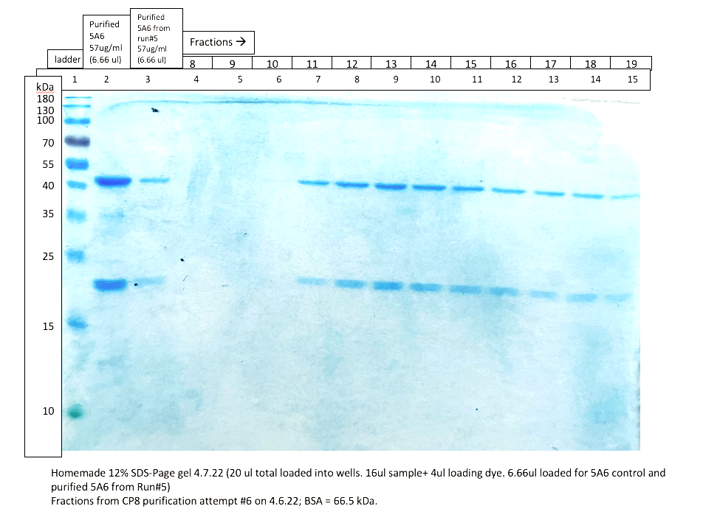

**B**

**C**



**A**

