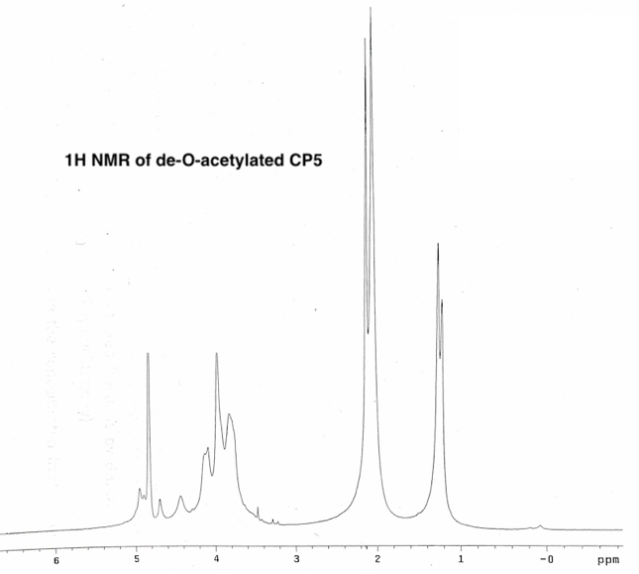

**ELISA inhibition Data:**

Primary antibody = CP5-specific rabbit antiserum that was absorbed with purified CP5.

**Description:**High molecular weight (Kav = 0.038) serotype 5 capsular polysaccharide purified from *S. aureus* strain Reynolds.

**Formulation & Storage:** lyophilized in sterile water; stored at -20C.

**Notes & Usage Guidelines:**

**Purity:** <1% protein

<1% nucleic acid

<1% phosphorus (indicative of contamination with wall teichoic acid)

[Services@ibtbioservices.com](mailto:Services@ibtbioservices.com)

PROTEINS

**Catalog #: XXXX**

**Related Products:**

IBT provides a wide array of anti-filovirus specific antibodies, recombinant proteins, and other infectious disease reagents. Please see our website, www.ibtbioservices.com for more details.

**Certificate of analysis:**

A hardcopy of datasheet is sent along with the products. Please refer to it for detailed information. For older lots, refer to the applicable certificate of analysis that may be requested at services@ibtbioservices.com

**Applications**

**Intended for research use only, not for human, therapeutic, or diagnostic applications.***The buyer cannot sell or otherwise transfer this product for Commercial Purposes without written approval of Integrated BioTherapeutics, LLC.*   
**Copyright 2023. Integrated BioTherapeutics, LLC. All rights reserved.**

**Lot #: 7**