**Monoclonal Antibodies (4C2) to S. aureus serotype 5 capsular polysaccharide**

Monoclonal antibodies (4C2) to *S. aureus* serotype 5 capsular polysaccharide

**Lots #: 1, 2, 3, and 4**

**Formulation & Storage:** undiluted antiserum; stored at -20C.

A

[Services@ibtbioservices.com](mailto:Services@ibtbioservices.com)

ANTIBODY

**Catalog #: XXX**

**Related Products:**

IBT provides a wide array of anti-filovirus specific antibodies, recombinant proteins, and other infectious disease reagents. Please see our website, www.ibtbioservices.com for more details.

**Certificate of analysis:**

A hardcopy of datasheet is sent along with the products. Please refer to it for detailed information. For older lots, refer to the applicable certificate of analysis that may be requested at services@ibtbioservices.com

**Intended for research use only, not for human, therapeutic, or diagnostic applications.***The buyer cannot sell or otherwise transfer this product for Commercial Purposes without written approval of Integrated BioTherapeutics, LLC.*   
**Copyright 2023. Integrated BioTherapeutics, LLC. All rights reserved.**

**Description:**Murine IgG1 monoclonal antibody (mAb) 4C2 recognizes the backbone structure of *Staphylococcus aureus* capsular polysaccharide type 5 (CP5). 4C2 mAbs were purified from hybridoma supernatants over protein G columns. Protein concentrations were assessed by BioRad protein assays, and mAb purity was confirmed by SDS-PAGE and ELISA.

**Notes & Usage Guidelines:  
Clonality:**

**Purity:** panel B

**ELISA:** Assay-dependent dilution. Seepanel C .

**Colony immunoblots:** mAb 4C2 (diluted 1:1000) was reactive with serotype 5 strains but nonreactive with coagulase-negative staphylococci and *S. aureus* isolates that produced CP8 or were acapsular (not shown; see *B. Liu et al, Virulence 2017).*

**Applications**

(B) Coomassie-stained SDS gel of 4C2 mAb showing heavy and light IgG chains. (C) Capture ELISA quantifying IgG concentrations of two batches of 4C2.

(A) Opsonophagocytic activity of CP5-specific mAbs 4C2 against wild type strain Reynolds (CP5) and a cap5H deletion mutant that produces O-deacetylated CP5. mAb recognizes the CP5 backbone structure, independent of O-acetylation.

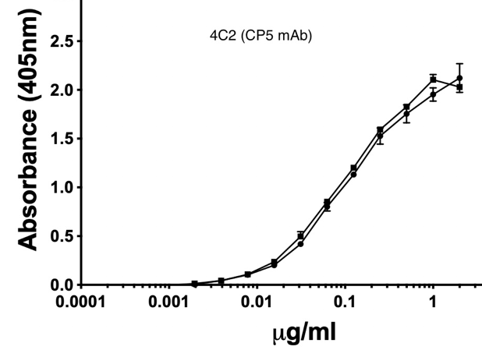

**B**

**C**

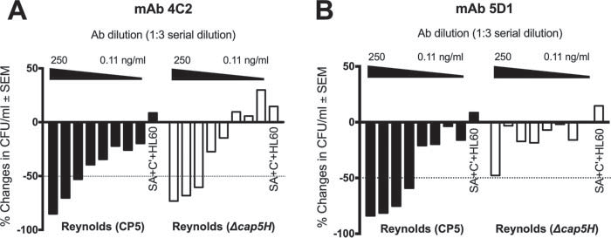

**A**