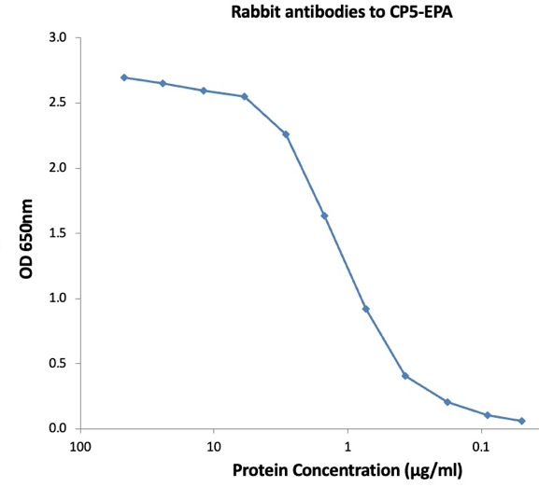N

**ELISA Data:** CP5 protein was diluted to X ng/well to coat plate. The rabbit Anti-Staphylococcus aureus CP5-EPA Antiserum was serially diluted, 2-fold from 50 µg/mL and incubated on the coated plates. The washed plates were detected with anti-rabbit IgG-X conjugate and TMB substrate. The OD650 shows strong signals against target protein CP5-EPA.

**Description:**Antiserum from rabbits immunized with *Staphylococcus aureus* capsular polysaccharide serotype 5 CP5-EPA conjugate vaccine and purified using Protein A column.

**Rabbit IgG to CP5-EPA**

[Services@ibtbioservices.com](mailto:Services@ibtbioservices.com)

ANTIBODY

**Catalog #: XXX**

**Related Products:**

IBT provides a wide array of anti-filovirus specific antibodies, recombinant proteins, and other infectious disease reagents. Please see our website, www.ibtbioservices.com for more details.

**Certificate of analysis:**

A hardcopy of datasheet is sent along with the products. Please refer to it for detailed information. For older lots, refer to the applicable certificate of analysis that may be requested at [services@ibtbioservices.com](mailto:services@ibtbioservices.com)

**Applications**

**Notes & Usage Guidelines:  
Clonality:** Polyclonal

**Purity:** Protein A purified

**ELISA:** Assay-dependent dilution

**Immunogen:***Staphylococcus aureus* capsular polysaccharide serotype 5 CP5-EPA

**Formulation & Storage:** Aqueous; ~10 mg protein/ml; Short-Term Storage: 4°C for 2-3 weeks; Long-term Storage: -20°C

A

**Intended for research use only, not for human, therapeutic, or diagnostic applications.***The buyer cannot sell or otherwise transfer this product for Commercial Purposes without written approval of Integrated BioTherapeutics, LLC.*   
**Copyright 2024. Integrated BioTherapeutics, LLC. All rights reserved.**

**Lot #: 9.4 or 10.3**