**Anti-Japanese Encephalitis Virus NS1 Antibody, JN1.**

ANTIBODY

**Catalog #: 0229-PP-001**

**Related Products:**

IBT provides a wide array of antibodies, recombinant proteins, and other infectious disease reagents. Please see our website, www.ibtbioservices.com for more details.

**Applications**

**Formulation & Storage: Store at** +4°C for stable

**Intended for research use only, not for human, therapeutic, or diagnostic applications.***The buyer cannot sell or otherwise transfer this product for Commercial Purposes without written approval of Integrated BioTherapeutics, LLC.*   
**Copyright 2023. Integrated BioTherapeutics, LLC. All rights reserved.**

[products@integratedbiotherapeutics.com](mailto:products@integratedbiotherapeutics.com)

**Description:**JEV non-structural protein 1 specific mouse monoclonal antibody. This monoclonal antibody reacts with a conformational epitope present on JEV NS1.

**Notes & Usage Guidelines:  
Clonality/Isotype:** monoclonal / IgG3, Kappa.

**Host:** Mouse

**ELISA:**   
**WB:**

**Immunogen/ Target:**JEV (Nakayama) infected supernatant followed by lysate booster.

This monoclonal antibody is intended for use in the western blot (non-reducing unheated conditions) and in an indirect immunofluorescence assay. It has been described in a JEV IgM capture ELISA for differentiating natural infections in a JEV vaccinated population.

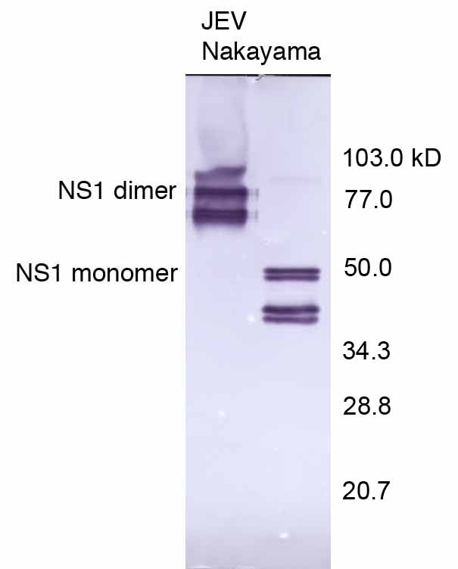

JEV (Nakayama) infected C6/36 lysate probed with JN1.

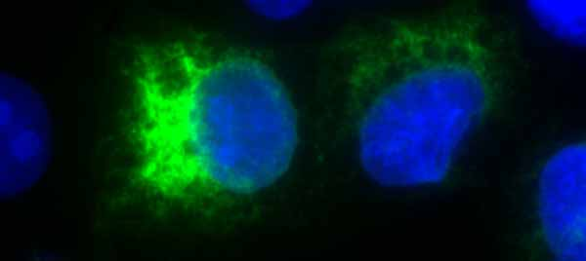

Immunofluorescence of JEV (Nakayama) infected PS Clone D cells with JN1.

**Certificate of analysis:**

A hardcopy of datasheet is sent along with the products. Please refer to it for detailed information. For older lots, refer to the applicable certificate of analysis that may be requested at services@ibtbioservices.com