**Anti-Japanese Encephalitis Virus Antibody, JE1.**

ANTIBODY

**Catalog #: 0228-PP-001**

**Related Products:**

IBT provides a wide array of antibodies, recombinant proteins, and other infectious disease reagents. Please see our website, www.ibtbioservices.com for more details.

**Applications**

**Formulation & Storage: Store at** +4°C for stable for a year

**Intended for research use only, not for human, therapeutic, or diagnostic applications.***The buyer cannot sell or otherwise transfer this product for Commercial Purposes without written approval of Integrated BioTherapeutics, LLC.*   
**Copyright 2023. Integrated BioTherapeutics, LLC. All rights reserved.**

[products@integratedbiotherapeutics.com](mailto:products@integratedbiotherapeutics.com)

**Description:**Japanese encephalitis virus specific mouse monoclonal antibody. This antibody reacts with a conformational epitope on the envelope glycoprotein of JEV.

**Notes & Usage Guidelines:  
Clonality/Isotype:** monoclonal / IgG2a, Kappa.

**Host:** Mouse

**ELISA:**   
**WB:**

**Immunogen/ Target:**JEV (Nakayama) infected supernatant followed by lysate booster.

This monoclonal antibody is intended for use in the IgM capture ELISA for the diagnosis of JEV IgM in patient serum samples. For the diagnosis of JE infections in regions where dengue co-circulates, this antibody is used together with the dengue specific monoclonal antibody, DE1. It is the JEV specific monoclonal antibody currently being used in the commercially available Japanese encephalitis IgM dot blot assay (Venture Technologies Sdn Bhd).

This monoclonal antibody may also be used in an indirect immunofluorescence assay for the detection of JEV antigens in infected cells.

It has been tested in other ELISA formats including a JEV IgM capture ELISA for the monitoring of JEV infections in pigs, a JEV antigen capture ELISA and the JEV IgG capture ELISA.

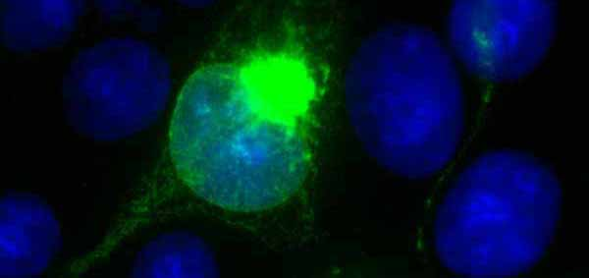

JEV (Nakayama) infected PS Clone D cells.

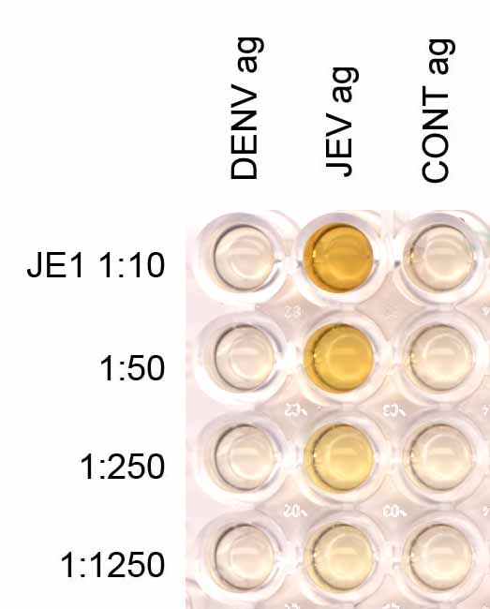

JE1 titration in an IgG capture ELISA.

**Certificate of analysis:**

A hardcopy of datasheet is sent along with the products. Please refer to it for detailed information. For older lots, refer to the applicable certificate of analysis that may be requested at services@ibtbioservices.com