**Anti-Dengue Virus prM Antibody, DM1.**

ANTIBODY

**Catalog #: 0225-PP-001**

**Related Products:**

IBT provides a wide array of antibodies, recombinant proteins, and other infectious disease reagents. Please see our website, www.ibtbioservices.com for more details.

**Applications**

**Immunogen/ Target:**DENV E and prM eluted from SDS-PAGE gels.

**Formulation & Storage: Store at** +4°C for stable

**Intended for research use only, not for human, therapeutic, or diagnostic applications.***The buyer cannot sell or otherwise transfer this product for Commercial Purposes without written approval of Integrated BioTherapeutics, LLC.*   
**Copyright 2023. Integrated BioTherapeutics, LLC. All rights reserved.**

[products@integratedbiotherapeutics.com](mailto:products@integratedbiotherapeutics.com)

**Lot #: 1**

**Description:**Dengue virus group-specific mouse monoclonal antibody. This monoclonal antibody reacts mainly with a conformational epitope present on DENV1, 2, 3 and 4.

**Notes & Usage Guidelines:  
Clonality/Isotype:** monoclonal / IgG1, Kappa.

**Host:** Mouse

**ELISA:**   
**WB:**

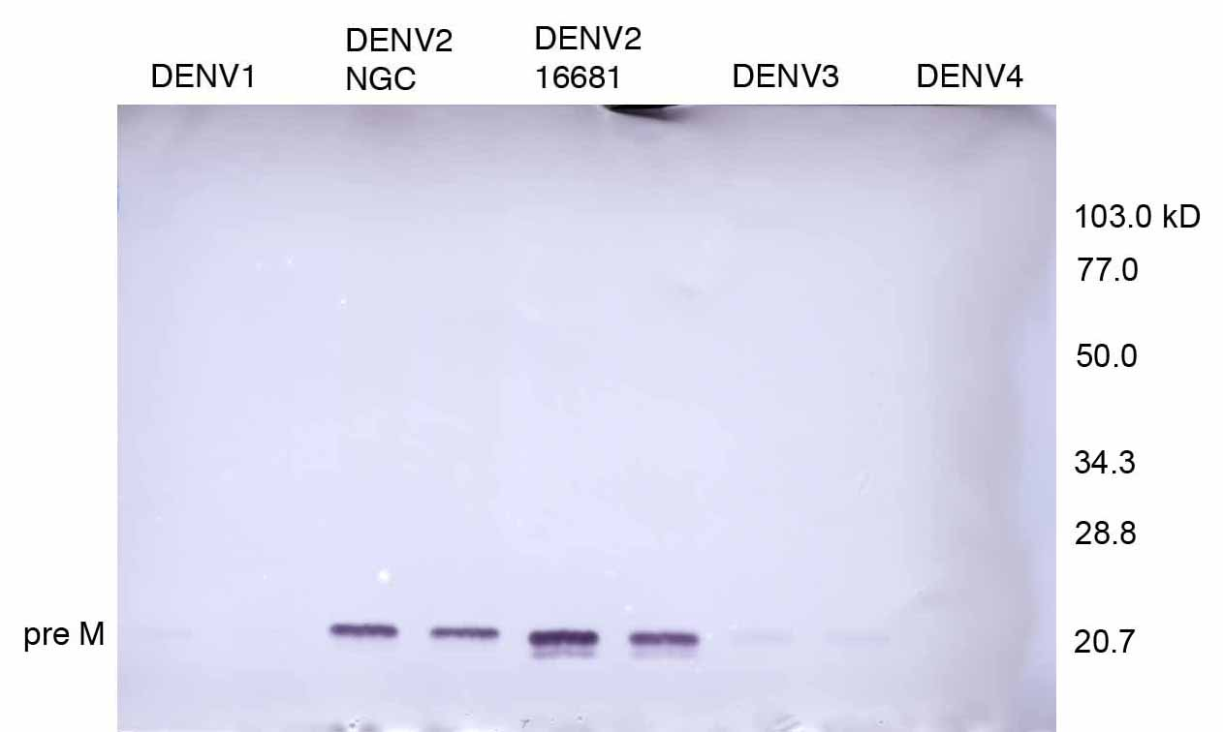

Dengue virus infected C6/36 lysates probed with DM1.

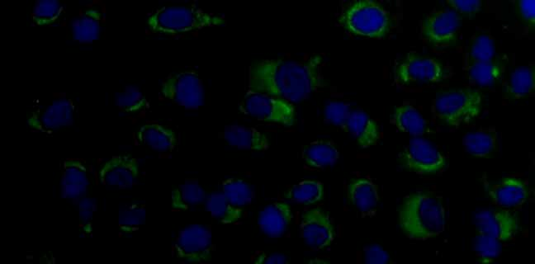

Immunofluorescence of DENV2 infected Vero cells with DM1.

This monoclonal antibody is intended for use in the detection of DENV prM by western blot (non-reducing unheated conditions) and immunofluorescence. However, detection of the prM band by western blot is highly dependent on the amount of prM present in the lysate preparation. In an antigen capture ELISA, the monoclonal antibody reacts with DENV1, 2, 3 and 4. It has been shown to react with native DENV1, 2, 3 and 4 prM by dot blot (customer feedback). Detects DENV1, 2, 3 and 4 by FRNT. Can neutralize DENV1, 2, 3 and 4 in a standard VERO PRNT.

**Certificate of Testing for:**

**Lot#: n/a**

**Volume:**

**Concentration:**