**Anti-Dengue Virus NS1 Antibody, DN1.**

ANTIBODY

**Catalog #: 0224-PP-001**

**Related Products:**

IBT provides a wide array of antibodies, recombinant proteins, and other infectious disease reagents. Please see our website, www.ibtbioservices.com for more details.

**Applications**

**Immunogen/ Target:**DENV2 (16681) infected supernatant followed by lysate booster.

**Formulation & Storage: Store at** +4°C for stable

**Intended for research use only, not for human, therapeutic, or diagnostic applications.***The buyer cannot sell or otherwise transfer this product for Commercial Purposes without written approval of Integrated BioTherapeutics, LLC.*   
**Copyright 2023. Integrated BioTherapeutics, LLC. All rights reserved.**

[products@integratedbiotherapeutics.com](mailto:products@integratedbiotherapeutics.com)

**Lot #: 1**

**Description:**DENV2 non-structural protein 1 specific mouse monoclonal antibody. This monoclonal antibody reacts with a conformational epitope present on DENV2 NS1.

**Notes & Usage Guidelines:  
Clonality/Isotype:** monoclonal / IgG2a, Kappa.

**Host:** Mouse

**ELISA:**   
**WB:**

This monoclonal antibody is intended for use in the detection of DENV2 NS1 by western blot (non-reducing conditions) and by immunofluorescence. Detects DENV2 by FRNT.

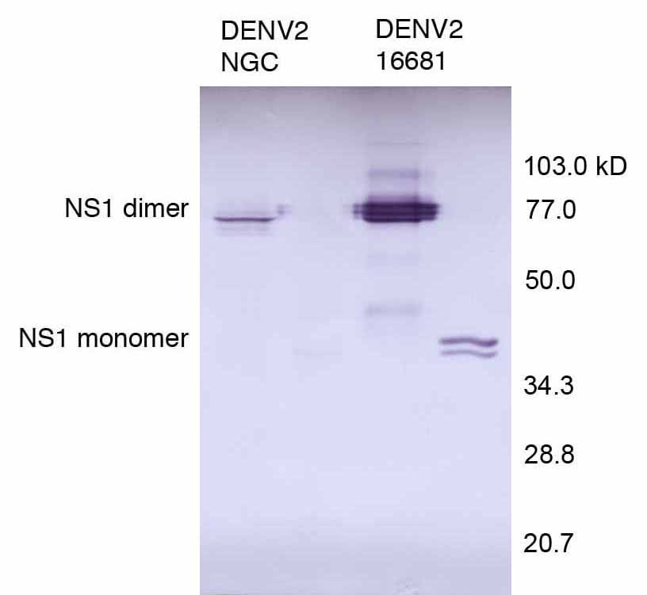

DENV2 infected C6/36 lysates probed with DN1.

**Certificate of Testing for:**

**Lot#: n/a**

**Volume:**

**Concentration:**