Anti-Dengue Virus E Antibody, DE7
ANTIBODY
Catalog #: 0223-PP-007
Related Products:
IBT provides a wide array of antibodies, recombinant proteins, and other infectious disease reagents. Please see our website, www.ibtbioservices.com for more details.

Applications

Immunogen/ Target:
Recombinant DENV E protein.

Formulation & Storage: Store at +4°C for stable

Intended for research use only, not for human, therapeutic, or diagnostic applications.
The buyer cannot sell or otherwise transfer this product for Commercial Purposes without written approval of Integrated BioTherapeutics, LLC.
Copyright 2023. Integrated BioTherapeutics, LLC. All rights reserved.

products@integratedbiotherapeutics.com

Description:
DENV E glycoprotein specific mouse monoclonal antibody. This monoclonal antibody reacts with a conformational epitope present in DENV1, 2, 3 and 4 E.

Notes & Usage Guidelines:
Clonality/Isotype: monoclonal / IgG1, Kappa.
Host: Mouse
ELISA:
WB:

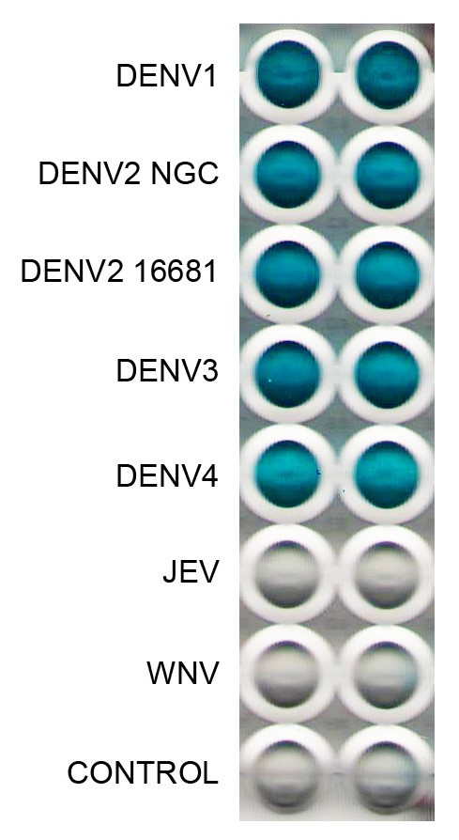

This monoclonal antibody has been primarily used for the detection of DENV1, 2, 3 and 4 antigens in an antigen capture ELISA. This monoclonal antibody is not suitable for western blot (non-reducing unheated conditions). Does not work very well in FRNT. Can neutralize DENV1, 2, 3 and 4 in a standard VERO PRNT.

Assay steps :
Anti-mouse Ig coated well
Blocked with BSA
Monoclonal antibody
Antigen sample
Polyclonal anti-flavivirus antibody
Conjugate
Substrate

Certificate of analysis:
A hardcopy of datasheet is sent along with the products. Please refer to it for detailed information. For older lots, refer to the applicable certificate of analysis that may be requested at services@ibtbioservices.com

