**Anti-Dengue Virus E Antibody, DE4**

ANTIBODY

**Catalog #: 0223-PP-004**

**Related Products:**

IBT provides a wide array of antibodies, recombinant proteins, and other infectious disease reagents. Please see our website, www.ibtbioservices.com for more details.

**Applications**

**Immunogen/ Target:**Recombinant DENV E protein.

**Formulation & Storage: Store at** +4°C for stable

**Intended for research use only, not for human, therapeutic, or diagnostic applications.***The buyer cannot sell or otherwise transfer this product for Commercial Purposes without written approval of Integrated BioTherapeutics, LLC.*   
**Copyright 2023. Integrated BioTherapeutics, LLC. All rights reserved.**

[products@integratedbiotherapeutics.com](mailto:products@integratedbiotherapeutics.com)

**Description:**DENV E glycoprotein specific mouse monoclonal antibody. This monoclonal antibody reacts with a conformational epitope present on DENV1, 2 and 3 E.

**Notes & Usage Guidelines:  
Clonality/Isotype:** monoclonal / IgG1, Kappa.

**Host:** Mouse

**ELISA:**   
**WB:**

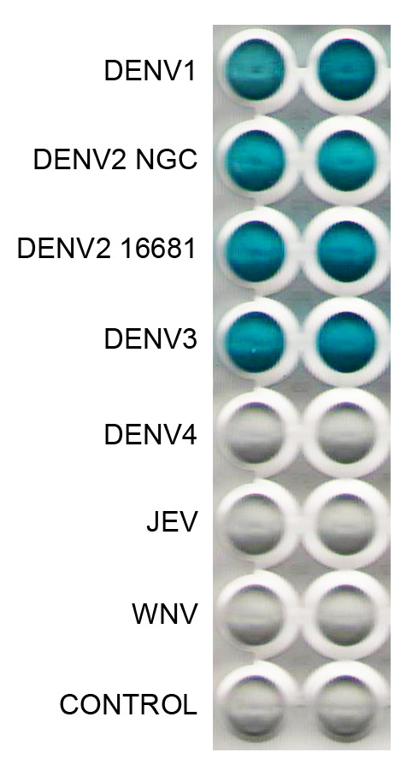

This monoclonal antibody has been primarily used for the detection of DENV1, 2 and 3 antigens in an antigen capture ELISA. Detects D3 by western blot (non-reducing unheated conditions) and FRNT.

Assay steps :

Anti-mouse Ig coated well

Blocked with BSA

Monoclonal antibody

Antigen sample

Polyclonal anti-flavivirus antibody

Conjugate

Substrate

**Certificate of analysis:**

A hardcopy of datasheet is sent along with the products. Please refer to it for detailed information. For older lots, refer to the applicable certificate of analysis that may be requested at services@ibtbioservices.com