**Anti-Dengue Virus Antibody, DE1**

ANTIBODY

**Catalog #: 0223-PP-001**

**Related Products:**

IBT provides a wide array of antibodies, recombinant proteins, and other infectious disease reagents. Please see our website, www.ibtbioservices.com for more details.

**Applications**

**Immunogen/ Target:**DENV2 (16681) infected supernatant followed by lysate booster

**Formulation & Storage: Store at** +4°C for stable

**Intended for research use only, not for human, therapeutic, or diagnostic applications.***The buyer cannot sell or otherwise transfer this product for Commercial Purposes without written approval of Integrated BioTherapeutics, LLC.*   
**Copyright 2023. Integrated BioTherapeutics, LLC. All rights reserved.**

[products@integratedbiotherapeutics.com](mailto:products@integratedbiotherapeutics.com)

**Description:**Dengue virus group-specific mouse monoclonal antibody. This monoclonal antibody reacts with a conformational epitope present on DENV1, 2, 3, and 4E.

**Notes & Usage Guidelines:  
Clonality/Isotype:** monoclonal / IgG2b, Kappa.

**Host:** Mouse

**ELISA:**   
**WB:**

**ELISA Data:**



DE1 titration in an IgG capture ELISA.

This monoclonal antibody may also be used in an indirect immunofluorescence assay for the detection of dengue antigens in infected cells. Does not work very well in FRNT. It has been tested in other ELISA formats including a dengue antigen capture ELISA and the dengue IgG capture ELISA. Optimal dilutions for usage should be determined by enduser. This monoclonal antibody is not suitable for western blot (non-reducing unheated conditions).

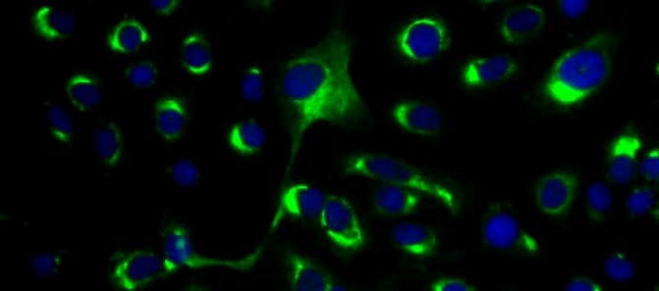

Immunofluorescence of DENV2 infected Vero cells

with DE1.

**Certificate of analysis:**

A hardcopy of datasheet is sent along with the products. Please refer to it for detailed information. For older lots, refer to the applicable certificate of analysis that may be requested at services@ibtbioservices.com