Viral Titration:
Serially diluted pseudoviruses in EMEM™ in a 2-fold series were added to Vero cells seeded in a 96-well plate at a seeding density of 6E4 cells/well. Cells with media alone were used as control. After 24 h, the infection was monitored using the Luciferase Assay System (Promega, Madison, WI, USA). Viral titer was calculated using a dilution that resulted in a Relative Luciferase Unit (RLU). The RLU value recommended for this product is based readout from the BioTek Cytation™ instrument. Absolute RLU obtained by the user may vary based on the user’s instrument & handling or luciferase assay system.

PSEUDOVIRUS

products@ibtbioservices.com

Applications

Intended for research use only, not for human, therapeutic, or diagnostic applications.
The buyer cannot sell or otherwise transfer this product for Commercial Purposes without written approval of Integrated BioTherapeutics, LLC.
Copyright 2023. Integrated BioTherapeutics, LLC. All rights reserved.

Recombinant Vesicular Stomatitis Virus pseudotyped with Ebola virus glycoprotein (rVSV-EBOV-GP)

Catalog #: 1001-001

Formulation & Storage: Supplied in EMEM™ (Gibco) supplemented with 1% Fetal Bovine Serum, L-glutamine and Penicillin/Streptomycin. Store at -80°C.

Description:
Recombinant Vesicular Stomatitis Virus pseudotyped with Ebola virus glycoprotein (rVSV-EBOV-GP) system in which the G protein of VSV has been deleted, replaced with firefly luciferase and used to produce VSV-pseudotyped virus containing the envelope glycoprotein of Ebola virus. Since the infectivity of pseudotyped virus is restricted to a single round of replication, analyses of viral entry can be performed using just biosafety level 2 (BSL-2) containment.

Notes & Usage Guidelines:
Recommended Dilution: 1:40
Luciferase Units for Assays: 30,000
Reporter: Luciferase

Pseudovirus Neutralization Assay Protocol:
The vesicular stomatitis virus (rVSV) whose glycoprotein gene (G) has been deleted and replaced with the viral glycoprotein of interest expressing a luciferase reporter allowing it’s use in a pseudotype-virus based neutralization assay.

A monolayer of Vero cells is infected with the virus or a mixture of virus and test sample for approximately 1 hr in a dilution block. Cells are overlayed with 1-2% FBS supplemented media and incubated overnight at 37°C + 5% CO₂. Following overnight incubation, luciferase activity is measured by adding an appropriate substrate like Bright-Glo™ or Luciferase Assay System (Promega). Plates can be read immediately on an instrument such as BioTek Cytation™ or similar. Relative neutralization activity is measured by comparing treated versus untreated wells (or virus only control). In dose response experiments the concentration of TA resulting in 50% neutralization (IC50) is determined.

Repeated freeze/thaw cycles are not recommended as it may affect viral titer and infectivity.

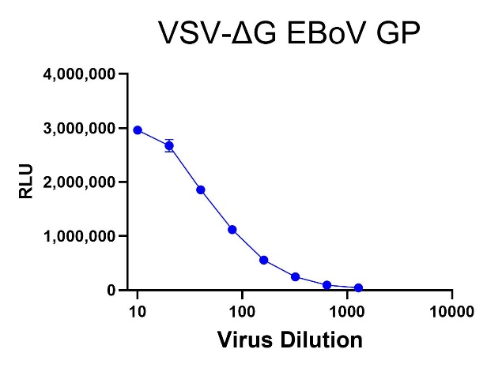
Related Products:
IBT provides a wide array of antibodies, recombinant proteins, and other infectious disease reagents. Please see our website, www.ibtbioservices.com for more details.

Certificate of analysis:
A hardcopy of datasheet is sent along with the products. Please refer to it for detailed information. For older lots, refer to the applicable certificate of analysis that may be requested at services@ibtbioservices.com

